**A PROJECT**

**REPORT ON**

**“INTERIOR DESIGNING USING**

**HTML & CSS & JAVASCRIPT”**

**Submitted by: Guided by:**

SAAD SHAIKH  **Mr.Yash Suthar**

MANAN SUTHAR

**Diploma in Computer Engineering**

**Submitted to:**

**Parul Polytechnic Institute**

**Post-Limda, Waghodia - 391760**

CERTIFICATE

This is to certify that Saad Shaikh & Manan Suthar of Diploma (1st semester) in Computer Engineering, Enrollment No. **T322CE165 & T1322CE152** has satisfactorily presented his/her project entitled “INTERIOR DESIGNING” for the term ending in November/December 2022.

PROJECT GUIDE: HEAD OF DEPARTMENT:

MR.YASH SUTHAR MRS.POONAM FALDU

**ACKNOWLEDGEMENT**

We take this opportunity to express our profound sense of gratitude and respect to all those who helped us throughout the duration of this project.

Firstly, we are extremely grateful to **Parul Polytechnic Institute**, for providing us the excellent working environment to undergo our project.

We devote our success in this effort to our project guide Yash Suthar for giving us the opportunity to undertake the project and providing crucial feedbacks that influenced us and provided opportunity to undertake the project work in the esteemed concern.

We are also deeply thankful to Mrs. Poonam Faldu, Head of Computer Engineering Department, whose useful suggestions, gentle soothing attitude and right directions helped us a lot to learn in this project and also for her constant encouragement and support throughout the project.

Last, but not the least, we would like to extend our profound thanks to all our esteemed colleagues and friends at college level who helped us in the specific areas of this project.

**ABSTACT­­­­­­**

Small homes may become more popular in the future due to rising costs and resource shortages .For some population segments smaller homes are especially attractive such as retired households wanting todownsize. A studio project was developed and given to Sophos more interior design students in which they wereasked to design a home of 1,000 square feet or under which was functional and aesthetically pleasing. Duringclass discussions students were provided with a number of design ideas that they could utilize in their designs. Theprojects displayed a variety of design techniques to visually enhance the size of space. The projects “My urbanfarm” and “My small house” were highlighted. Students were excited with their attempts to create small homesfor themselves.

**INDEX**

|  |
| --- |
| INTRODUCTION |
| DESIGN OBJECTIVE |
| APPROACH AND EXECUTION |
| FUNCTIONAL CRITERIA |
| GENERAL CONSIDERATIONS |
| SUBMITTAL REQUIREMENTS |

**INTRODUCTION**

We have made this project using:

* HTML
* CSS
* JS

**What is HTML?**

* HTML is Hyper Text Markup Language.
* For document designed to be displayed in web browser.
* It can be assisted by technologies such as CSS & JS.

**What is CSS?**

* CSS is Cascading Stylesheet.
* It is a language used for describing presentation of a document written in HTML.
* It is used to style and layout webpage.

**What is JS?**

* Java Script often known as JS.
* It is a programming language that is one of the core technologies of WWW (World Wide Web).
* You have two option to execute the JS.
* JS is used for animation.



**A.PURPOSE**

This Approach to interior design. Use it to

Educate and assist base designers, design agents, and

Architectural/engineering firms working on all interior renovation and new construction projects.

**B.PHILOSOPHY**

Quality interior design reflects “understated

Excellence” and assures that our facilities are attractive, environmentally safe, operationally efficient, and maintainable. The interior designer must strive for sound economical, functional, and aesthetic design achievements. Well-designed facilities satisfy the user’s needs, Install pride of ownership, and promote productivity in the workplace.

**C.DESIGN GUIDE SCOPE AND USE**

It is our goal to design facility interiors that meet or exceed the user’s expectations for attractive, functional facilities. The design Objectives section is intended to provide a clear understanding of this goal to all members of the design team—from the commander to the interior designer and the user.

This guide also includes criteria for providing structural and comprehensive interior designs for us facilities:

• Structural Interior Design (SID) – This process involves the selection and coordination of interior materials and insides that are part of the building or are built-in items

(i.e., cabinets, equipment, etc.).

Comprehensive Interior Design (CID) – This process

Involves designing, selecting, and developing interior

Building materials, finishes, special effects, and furnishings for an integrated visual design theme (architectural and interior design). CID requirements, therefore, include structural interior design items and graphics. Furnishings include furniture, artwork, interior plants, trash receptacles, water fountains, chalk and tack boards, signs, entry directories, window coverings and other similar items.

Integrate engineering, architectural, and interior design considerations to create a “seamless” interior. The structural, electrical, and mechanical systems enhance the architectural and interior design features and vice versa. The goal is to create a fully integrated environment where the occupant loses sight of “how” and “why” the facility works and simply enjoys being there.

**A. FUNCTION**

Functional interior design ensures that each aspect of the interior environment performs efficiently for the user. A good working relationship between the user and designer will help accomplish this goal. Each facility type presents unique functional requirements that will ultimately affect the selection of finish materials and furnishings. It is important for the designer to investigate all aspects of these requirements through the user.

**B. COST EFFECTIVENESS**

All interior selections must reflect the “best buy” for the

Air Force in terms of aesthetic value and life-cycle costs.

Inexpensive, short-term solutions do not necessarily produce cost savings over time.

**C. DURABILITY**

Durable designs and finishes help facilities pass the “test of time.” The designer must be concerned with material durability and wear as well as cost. Select quality materials and products appropriate to the

function and level of use. Extra consideration must be given to products specified in heavy-use areas and specific functional areas.

**D. MAINTAINABILITY**

The use of easily maintained finishes is critical. While certain finishes may provide excellent durability, the designer must give serious consideration to maintenance and the effort required to maintain the appeal of certain products.

**E. COMPATIBILITY**

The designer must be familiar with the base’s architectural and environmental compatibility plans to achieve a unified sense of scale, tradition, and compatibility. The design team needs to understand that occasionally conditions exist which may limit

the ability to meet the compatibility standards, especially when dealing with historic buildings.

**F. DESIGN**

Facilities must meet as many “human” needs at as many levels as possible, especially the need to feel good about one’s surroundings. Work and living environments are increasingly within the control of those who design and build them. In the work place, the design team’s responsibility is to provide a facility which fosters productivity and job satisfaction. Well-designed interiors can provide an environment that contributes to achievement at work and enhances pleasure and relaxation in recreational facilities.

**G. CREATIVITY**

Budget constraints place increased importance on design creativity. Proper planning and research of innovative design features will help the designer provide quality facility interiors within restricted budgets.

**H. FLEXIBILITY**

Flexible designs are essential to meet the dynamic requirements our mission. While the primary function of each facility must be the priority, the designer must keep in mind that functions evolve, and facilities may require future modifications. Flexibility within building systems will reduce the amount of time and money required for future alterations.

Rapid technological advancements often demand upgraded equipment, power, and communication requirements. These advancements in technology should enhance, rather than outpace, the usefulness of facilities.

**I. TIMELESSNESS**

A sense of timelessness in facility design will extend the life and usefulness of design projects. Structural expression, suitability of materials, harmonious visual and tactile features, and classic furnishings will always remain the foundation of good design. The selection of trendy or dated finishes or design features is contrary design philosophy. Interiors should be creative but not extreme, reflect quality but not opulence, and be capable of being updated without requiring major changes to materials, spaces, or functions.

**APPROACH AND EXECUTION**

**A. PROGRAMMING**

To meet a facility’s functional requirements, the designer must define the facility function and understand the user’s needs.

The designer accomplishes this by using communication skills, technical knowledge, and artistic talent.

1. **Functional Requirements** - facilities can be divided

Into several major groups, including residential, hospitality / lodging, food service, office / administrative, Maintenance / warehouse, recreation, medical, and educational.

**2. Understanding the User’s Needs**

The designer must visit the project site, get to know the user, and gather data about the function, occupancy, and the user’s expectations. This can

be accomplished through meetings, surveys, and research.

a**. Meetings** - These include, but are not limited to, conferences held for predesign, presentation of concept, and review of various stages of project development.

b. **Surveys -** These can be performed by face-to-face interviews or written questionnaires. Surveys are an efficient way of gathering information concerning:

◆ Expected occupancy

◆ Types of duties or operations involved

◆ Individual space and equipment requirements

◆ Shared or common space and equipment requirements

◆ Interrelationships of people and functions within the facility space.

◆ Special equipment requirements and locations

◆ Future requirements

◆ Unusual circumstances affecting the design

c**. Research** - The interior designer must follow all applicable Air Force instructions, policies, and pamphlets, as well as building, fire, and safety codes and regulations.

B. **CONCEPT DEVELOPMENT**

As the user’s requirements become clear, the interior designer begins to formulate solutions for the design. In the concept development phase, those ideas begin to take form through:

1**. Space Planning** - What happens within a space determines the perception and experience that the user will encounter.

Some important considerations for space planning include:

a**. Personal space** - Provide for the personalization of each user’s space for display of personal items within limits.

Provide individual lighting whenever possible.

b**. Functional relationships** - Take into account the different groups of people and their working relationships.

c**. Adjacency priorities** - Identify and prioritize which

Employee groups need to be located adjacent to each other.

**2. Architectural Design**

**a. Codes and regulations** - Life safety and fire codes and regulations must be followed in all designs.

◆ Identify all applicable codes early in a project to minimize the need for reselections or rework.

◆ Be aware that codes apply to furnishings as well as finishes.

◆ Ensure that all designs meet Uniform Federal Accessibility Codes and comply with the Americans with Disabilities Act.

**b. Location influences** - There may be site specific factors which influence design solutions. It is the designer’s responsibility to identify which factors need consideration and determine the best method of addressing each. These include, but are not limited to:

◆ Architectural compatibility with existing facilities – The local parameters determining a facility’s exterior features will affect the size and type of windows, the

ceiling heights, and to an extent, the materials carried into lobbies, foyers, and other internal spaces. The designer must work with the project architect to ensure the complete coordination of interior and exterior designs for the best interest of the user and the function of the space.

◆ Historical preservation requirements - The National

Historic Preservation Act requires federal agencies to consult with the State Historic Preservation Officer and the Advisory Council on Historic Preservation regarding proposed changes to properties listed on or eligible for listing on the National Register of Historic Places.

The Secretary of the Interior Standards for the

Treatment of Historic Properties provides guidelines or making sure that selections do not compromise a facility’s historic integrity.

◆ Cultural beliefs and customs - Many nationalities and religious groups attach significance to certain

Colours, patterns, and materials. Some are considered sacred, good influences, and prestigious, while others are considered taboo. For instance, most Western cultures consider black the colour of mourning. Eastern/Oriental cultures associate.

**d. People relationships** - Identify the relationships and interactions of individuals within a group.

**e. Status and function** - Identify special requirements for circulation, public/private space separation, VIP areas, informal gathering spaces (coffee bars, break rooms, and shared equipment space), and storage (filing, coats, supplies, etc.). The occupant’s rank or position will influence the square footage and selection of materials.

**f. Equipment usage** - Identify all equipment and its users within each facility or each area of the facility.

**g. Efficient use of space** - Maximize the use of all spaces for their functions.

**h. Flexibility within the space** - Recognize that future

◆ Current mission - Often the mission of the user dictates certain design features. For example, sometimes windows are downsized or even eliminated. In these cases, designers need to emphasize other architectural elements and finishes to ensure a pleasant atmosphere for the users.

◆ Availability of materials and resources - Some materials are not readily available nor economically shipped to all locations. When designing a project for remote locations, consider cost and availability before specifying a product.

◆ Special climatic and/or maintenance problems

Sometimes the designer must take into account local climatic conditions when selecting materials and finishes. Special maintenance requirements must be identified when the following factors exist:

• Heavy snow or rain

• Very arid or humid climates

• Unusual soil conditions and sand

• High level of sun exposure

◆ Noise levels - Proper acoustical design depends on a careful ratio of reflective to absorptive surfaces so that excessive reverberation and disturbing sound intensity levels can be eliminated. The type of noise disturbance and function of the space will determine the adequate level of sound control.

◆ Security requirements - The user must provide any special security requirements that need to be included in the project. The user must validate and provide information from the appropriate agency, for example the Security Police, before design begins. When dealing with facilities that have special security needs, security clearances might have to be obtained.

c. **Light -** Light and its effects on the environment are critical to the interior design of a space. The quality and placement of light sources are as important as light level in obtaining the functional and the aesthetic intent of the spatial design. Be aware of how the light source affects space perception, finishes, colours, and textures when making design decisions. The function of the room or facility will influence the system type and amount of lighting required.

d. **Colour Concept** - Colour preference is very personal, and individual interpretation of colour varies widely. However, the true properties of colour are constant. The designer must have knowledge of these properties and their relationship to the functional, spatial, and lighting aspects throughout the space.

The designer and the user must separate personal taste from professional design. The following general guidance directs attention to special areas of consideration when selecting colour schemes for facilities.

a. Provide timeless colour coordination that will be attractive to the majority of people.

◆ Use neutral colours for permanent background finishes (e.g., architectural materials—ceramic tiles, stone, bathroom fixtures, panel fabrics etc.) to support a variety of colour schemes.

◆ Vary the intensity of colour and create patterns to provide visual relief from the monotony of neutral colours.

◆ Use accent colours for finishes that are subject to periodic change (carpets, wallcoverings, upholstery, etc.), and to create interest in focal points.

◆ Use pattern and texture to enhance visual interest.

◆ Provide small amounts of intense colours in graphics, borders, accessories, and artwork for visual stimulation.

b. Use colour to enhance the spatial qualities of an area.

◆ Use warm colours to make a room seem smaller, more “human” in scale; warm colours appear to advance toward the viewer.

◆ Use cool colours to make a room seem larger, and more spacious; cool colours appear to recede from the viewer.

**5. Material Selection**

a. **Durability** - The function of the space will determine the degree of durability required. The aesthetics and how the finish/material relate to the other design elements must also be considered, as well as cost justification.

b. **Maintenance** - The use of easily maintained finishes is critical. While certain finishes may provide excellent durability, the designer also must give serious consideration to maintenance requirements.

◆ Supplying manufacturer suggested maintenance information.

◆ Emphasizing the importance of a regular maintenance schedule.

◆ Indicating special products required for the maintenance program.

c. **Life cycle cost and appeal** - The designer must consider product performance and longevity of appeal,

as well as initial cost when making selections. If the appeal of a surface or furniture item degrades, the user will want to replace it prematurely. A product that keeps its appearance and shape longer may be a better choice over time.

**D**. **Product quality and performance** - Numerous studies show that quality does not necessarily have to cost more.

Quality products perform better and wear longer. Usually these products are backed by manufacturers’ warranties to assure the customer’s continued satisfaction after installation is complete.

e. **Environmental factors** - Designers today must consider the effects their selections have on the environment over time.

◆ Consider products that are made from recycled materials, or are easily recycled.

**C**.**DESIGN DEVELOPMENT**

At this point in the process, the interior designer should have a clear picture of the design intent. Through the design development process, the designer must complete the following:

1. **Design Narrative** - Write an explanation to help the user understand the design and selections that have been made.

2. **Design Illustration** - Provide floor plans, elevations,

Perspectives, and detail drawings.

3. **Colour Schemes and Material** - Provide finish boards or books to illustrate the colour scheme.

4. **Furnishings Selection** - Provide furniture and accessory boards or books to illustrate the colour concept.

D. **CONCEPT PRESENTATION**

The user’s satisfaction is an important goal, in addition to the longevity of the design. Educate the user to appreciate the long-term value of quality design. Explain the design development process and the designer’s role to the user.

**E. DESIGN EXECUTION**

The completed design package must clearly convey the design intent. The contract documents provide the information necessary to implement the design. These documents include:

1. **Statement of Work** (SOW) - A brief but through description of the work to be performed by the contractor. The SOW is used by the contracting agent to synopsize the project in the bid advertisement.

2**. Architectural Floor Plan** - Demolition plans, new floor plans, and reflected ceiling plans.

3**. Finish Schedule and Colour Legend** - The matrix indicating which finishes are used on specific interior surfaces, and the list identifying each finish by pattern, colour, number, brand and manufacturer.

4**. Finish Floor Plan** - A drawing typically used to clarify the placement of patterns, borders, or combinations of floor finishes in an area.

5. **Elevations, Sections, and Details** - Drawings used to further clarify a design feature. Elevations are drawings which typically illustrate placement of wallcovering as well as height of chair rails, bumper guards, plumbing fixtures, and other design features permanently attached to the walls. Sections and details generally illustrate how a particular feature is constructed or attached to another surface or feature, and of what generic materials it is made.

6. **Miscellaneous Drawings** - Electrical layouts, enlarged floor plans of rest rooms and repetitive areas (e.g., dorm rooms), and construction drawings for built-in cabinetry, etc.

7**. Furniture Floor Plan** - Scaled layouts showing placement of existing and new furniture and equipment. Separate drawings may be required for conventional furniture (modular or “freestanding” items) and systems furniture (panel mounted workstations, generally prewired). These drawings provide references for changes or decisions required during project construction.

8. **Installation Plans** - Drawings indicating the placement of systems furniture panels, electrical connections and power layouts, and components.

* **PHOTO OF MY WEBPAGE OUTPUT:**

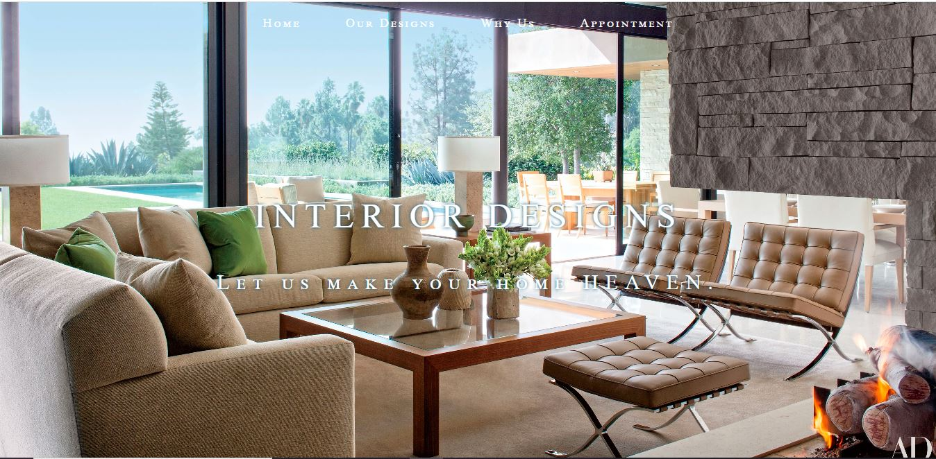

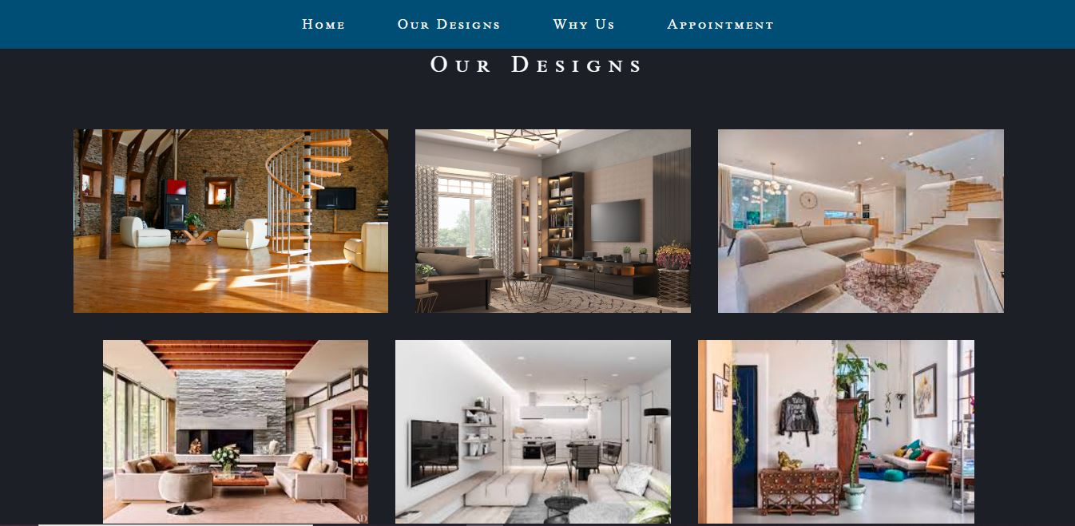

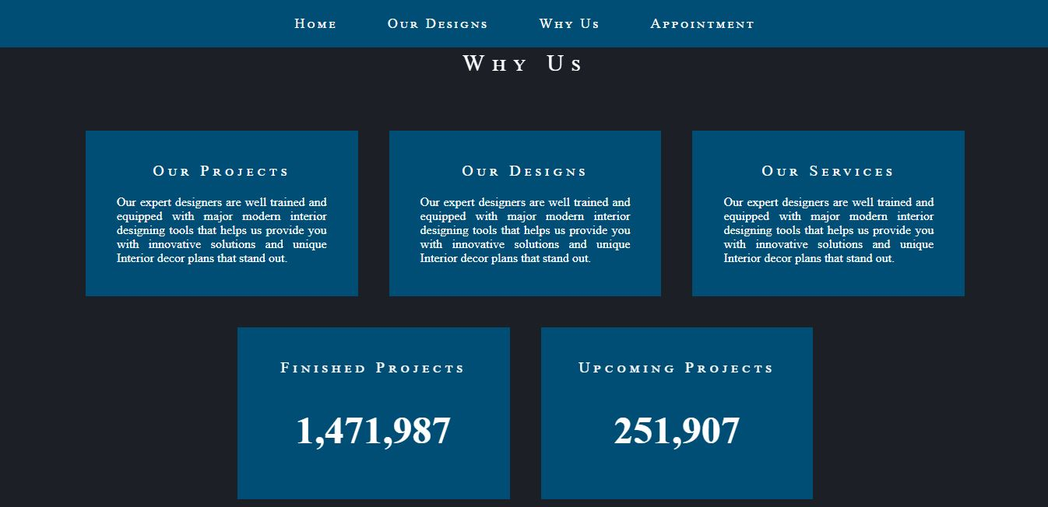

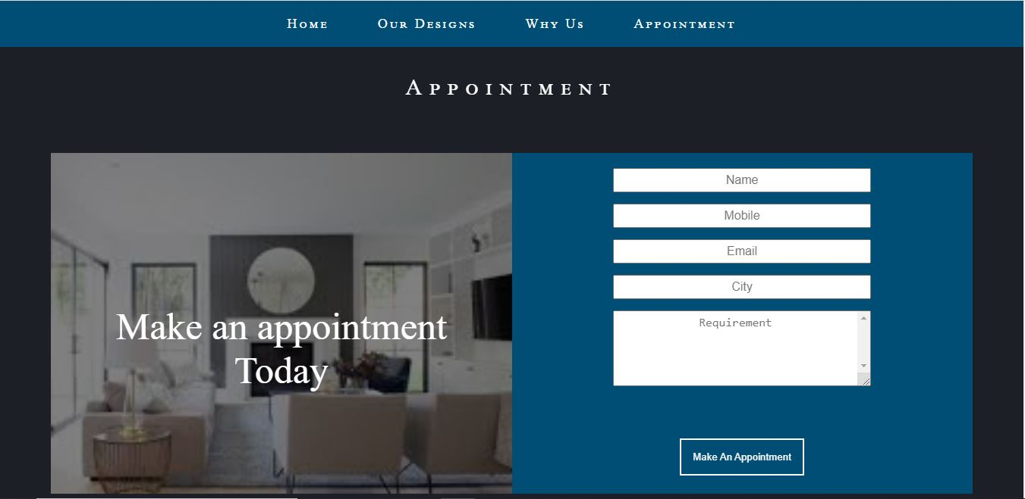

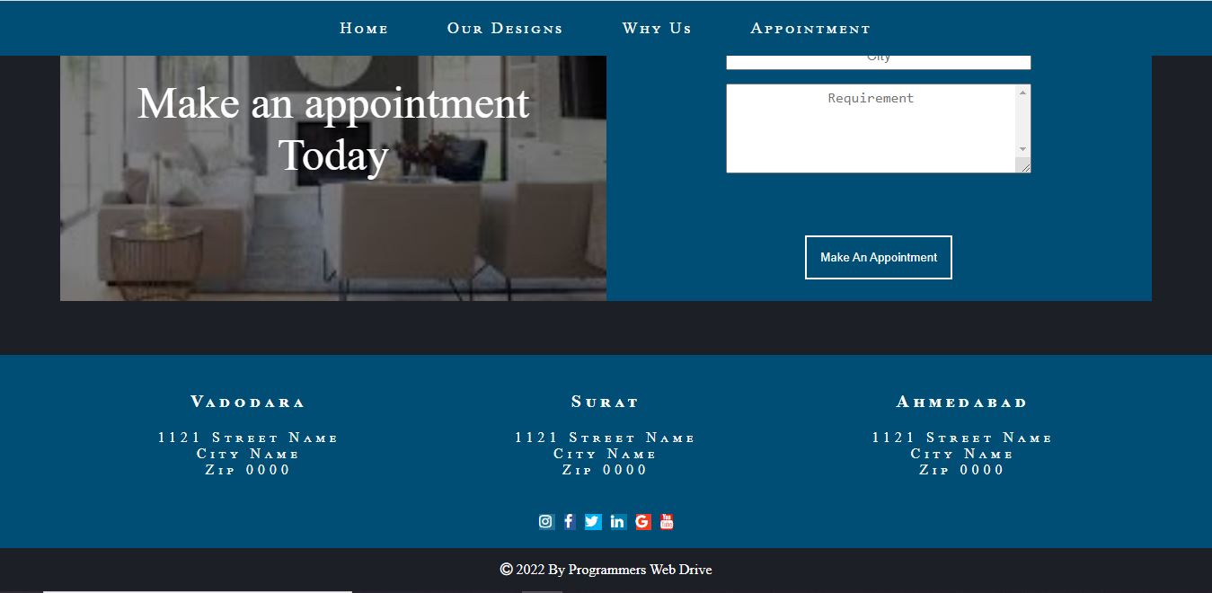

**THANK YOU**

**Karma unites us with god!**

**The Purest form of knowledge is attained by sharing it.**

**It gives us the strength to travel from darkness to light.**

**-----x-----x-----x-----x-----**